Governance and Management Policy

QUALITY AREA 7: GOVERNANCE AND LEADERSHIP

Date Created: October 2007 Date to be reviewed: January 2024 Version No: 10

Policy Statement:

The Management Committee of Yarrunga Early Learning Centre is responsible for the direction of the Centre and its effectiveness. The Management Committee meets monthly and works to ensure good governance by:

* Conducting our affairs legally, ethically and with integrity.
* Identify organisational risks and legal obligations and manage these through
* policies and relevant processes; and
* Ensure the mechanisms are in place for fair and transparent governance.

Background:

It is important for the legal and effective functioning of the Centres that Committee members understand their roles and are aware of their responsibilities.

Scope:

This policy applies to all members of the Centre’s Management Committee and is for the information of the Centre Director, staff and families using the service.

Relevant legislation:

Education and Care Services National Regulations.

Education and Care Services National Law Act 2010.

NSW Department of Fair Trading and The Associations Incorporations Act 2009.

Location of information:

This information is located on the Yarrunga web page, in the Committee Handbook and extracts are also included in the Parent Information Booklet and Staff Handbook

Reference sources:

Community Child Care Cooperative NSW – A Director’s Manual. *Managing an Early Education and care services in NSW*, 2013

Key Resources:

CELA Sample Policy 2019

Enterprise Care Consulting Group – *The Not for Profit Board and Management Guide* (2003 – loose leaf with regular updates) [www.enterprisecare.com.au](http://www.enterprisecare.com.au) (March 2006)

Strategies:

Introduction:

**Management Committee Role**

The Management Committee has overall responsibility to members for the sustainability and relevance of Yarrunga. The Management will direct its activities towards achieving Yarrunga’s goals and implementing Yarrunga’s Quality Improvement Plan by guiding and monitoring the centre’s business and affairs in line with the objects as set out in the constitution and in line with Yarrunga’s philosophy.

In carrying out its responsibilities, the Management Committee undertakes to maximise the value and contribution of Yarrunga to the community, and to serve the interests of our members, employees and families and children using Yarrunga. In serving these interests there is an implicit understanding that the rights of the child are paramount in all decision making.

The Management Committee is the employer of all staff of Yarrunga Early Learning Centre and are responsible for the management and control of the service as the Approved Provider of Education and Care under the Children (Education and Care Services National Law Application) Act 2010 and the Education and Care Services National Regulations.

The Centre receives public funds and government licenses and is in whole accountable to its members, both Federal and State governments and the community at large.

Federal and state governments

Community/parents

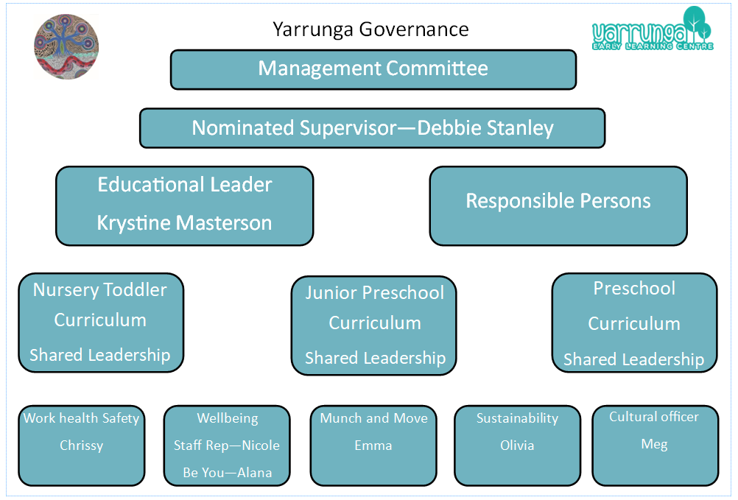

**Policies and Procedures**

**The Management Committee will:**

* Ensure that a comprehensive set of policies are in place as required under Education and Care Service Regulations and other Regulations and laws that the service must comply with. A sub-committee will be formed to assist with this task.
* Ensure that these policies comply with relevant legislation; and
* Update these policies on a regular basis. Any proposed changes, alterations will be advertised via newsletter and made available for perusal by the parent, staff body two weeks in advance of the set meeting date.
* The Director will ensure all staff have knowledge of the Policies and Procedures and are made aware of any changes that are made during reviews.
* All new, altered Policies will be discussed and ratified at Management Committee Meetings prior to being actioned.

**Compliance Measures**

**The Management Committee will:**

* Ensure that mechanisms are in place such as compliance tools and a compliance calendar to assist them to assess that the service’s policies are implemented; and
* Prepare an ‘orientation kit for new committee members’ from CCSA webpage [www.ccsa.org.au/members-article/orientation-kit-for -new-members/](https://yarrungaelc.sharepoint.com/Shared%20Documents/DATA/Master%20documents/Policies/7.%20Governance%20and%20Leadership/www.ccsa.org.au/members-article/orientation-kit-for%20-new-members)

**Constitution**

**The Management Committee of the Association will:**

* Ensure that Yarrunga Early Learning Centre Inc constitution/articles of association is/ are followed at all times.
* Ensure that the constitution/ articles of Yarrunga are reviewed at least every three years; and
* Ensure that each new member of the Management Committee is provided with a copy of Yarrunga Early Learning Centre’s constitution and Quality Improvement Plan on their appointment to the Management Committee.

**Management Committee Powers**

The Management Committee sets the strategic direction and monitors performance of the service. The Management Committee will provide effective governance to ensure excellent overall management of Yarrunga’s business and financial objectives.

In addition, the Management Committee members may delegate any of their powers (with the exception of the power and responsibilities of the Committee’s role as Approved Provider) to any other person for advice or guidance on projects.

The Management Committee delegates the responsibility of implementing the strategic plan and day-to-day management of Yarrunga to the service’s Director.

In discharging its powers, each Director/Management Committee member will be bound by the Associations Act/Corporations Act, the Constitution and all policies of the organisation.

The Management Committee’s authority includes:

* Overseeing the organisation including its control and accountability systems.
* Appointing and removing the Director.
* Ratifying the appointment of all staff members.
* Developing organisational strategy and performance objectives.
* Reviewing, ratifying and monitoring systems of risk management and internal control, codes of conduct, and legal compliance.
* Monitoring the Director’s performance and implementation of strategy.
* Approving and monitoring financial and other reporting.
* Authorising appropriate delegations within the organisation.
* Ensuring appropriate resources are available to carry out Yarrunga’s functions; and
* Approving and monitoring the progress of major capital expenditure.

**Risk Management**

**The Management Committee will:**

* Ensure Yarrunga Early Learning Centre operates with and to a valid Constitution/ Articles of Association and that all governance and management practices of the Management Committee and staff align with the Constitution/Articles of Association. Demonstrate achievement of this through accessible meeting minutes and Management Committee self-assessments; and
* Assist Committee members to receive ongoing support and professional development in the implementation of effective and evidence-based governance practice

**Code of Conduct**

**Management Committee members will:**

* Commit themselves members to ethical, businesslike, and lawful conduct, including proper use of authority and professional decorum when acting as Management Committee members.
* Demonstrate un-conflicted loyalty to the interests of Yarrunga when acting as a Management Committee member.
* Avoid conflicts of interest with respect to their role.
* Annually disclose their involvement with other organisations or companies that currently do business or may do business with Yarrunga.
* Immediately disclose to the Management Committee any and all impending conflicts of interest. That member shall absent herself or himself without comment from both the deliberation and final decision-making.
* Not use information exclusive to Management Committee members for personal gain and will respect the confidentiality of all information obtained during meetings or through their role; and
* Respect the confidentiality appropriate to issues of a sensitive nature.
* Put the needs and interests of the Centre ahead of personal perspectives when involved in decision making related to the Centres.
* Perform the tasks, assignments delegated within the Committee
* Provide strong support for the agreed strategies, decisions of the Committee
* Attend meetings on a regular basis.
* Sufficiently prepare for meetings to enable informed debate and decision-making.
* Understand and have empathy with the Centre’s history and current operations.
* Work impartially, collaboratively and harmoniously with other Committee members, Centre Director, staff and families.

The following is an overview of the general roles/responsibilities of all Committee members and those of the key office bearers.

***1.0 President***

*1.1 Status*

The President’s appointment is drawn from the membership of the Centre and is elected by members at the Annual General Meeting (AGM). Australian Children’s Education and Care Quality Authority (ACECQA) will submit online notification within one week of any changes of President (Approved Provider) and contact details etc. at Yarrunga Early Learning Service.

*1.2 Term of Appointment*

According to the Rules/Constitution

*1.3 Key Function*

To lead the Centre and be responsible for the integrity of Committee processes and decisions, including effectiveness of meetings and Committee governance.

*1.4 Role*

* Be the Committee’s delegated authority as Approved Provider of the Centre
* Be responsible for the license conditions for the Centre if there is no Authorised Supervisor employed.
* Lead the Centre’s vision and mission and achievement of organisational goals
* Chair Committee and General Meetings of the Centre
* Act as spokesperson for the Centre to media, government and other agencies
* Work in partnership with the Centre Director to ensure Committee decisions are carried out
* Lead recruitment and orientation processes of new Committee members and Centre Director
* Coordinate Centre’s Director annual work plan and performance evaluation
* Ensure the Centre’s compliance with all statutory requirements (Child & Young Persons (Care and Protection) Act 1998 (CYPCP Act), Child Protection (Prohibited Employment) Act 1998 and Education and Care Services National Regulations)
* To liaise with the Director in regard to staff issues
* Act as mediator in grievances involving the Director and ascertain strategies to reach suitable outcome of the parties involved.
* Liaise with executive committee to make decisions on urgent or confidential matters. These decisions will be discussed and ratified at the next Management Committee Meeting.

***2. Public Officer***

*2.1 Status*

The Public Officer does not have to be a committee member or even a member of the organisation – they do, however, have to be a reliable person with an interest in the Centre. The position of public officer is not allowed to remain vacant for more than 14 days and Department of Fair Trading must be notified if the position changes. Yarrunga’s Public Officer is Genna Richter, the President of the Management Committee.

*2.2 Term*

According to the Rules/Constitution.

***2.3 Key Function***

To act as the official contact point for the Centre. The public officer’s home address is the official address to which any formal documents (such as court orders or summons) will be sent.

*2.4 Role*

* Keep a register of the organisation’s current committee members at their home
* Notify the Department of Fair Trading of changes to the association and its financial situation
* Contact for the Australian Taxation Office in relation to any required information.

***3 Treasurer***

*3.1 Status*

The Treasurer’s appointment is drawn from the membership of the Centre and is elected at the AGM.

*3.2 Term*

According to the Rules/Constitution

*3.3 Key Function*

To oversee the Centre’s financial reporting, prepare annual budget, monitor profit and loss and that correct accounting procedures are in place to ensure the viability of the Centre and keeping the committee informed about the financial state of the Centre.

*3.4 Role*

* Lead the Committee’s review of and action related to the Committee’s financial responsibilities.
* Provide or work with the Centre Director and any contracted finance personnel to ensure that monthly financial reports are made available to the Committee on a timely basis and documents lodged as required.
* Work with the Centre Director and the contracted finance personnel to prepare the annual budget and present the budget to the Committee for approval
* Effectively monitor the income and expenditure (profit/loss) against the budget and provide advice to the Committee of any significant implications
* Ensure that appropriate internal financial controls are in place and operate effectively
* Present financial reports at committee meetings and the annual financial report and audit to the Annual General Meeting
* Ensure that a copy of the organisation’s annual audit and other financial returns are sent to relevant funding bodies and government departments.

***4. Vice President***

*4.1 Status*

The Vice-President’s appointment is drawn from the membership of the Centre and is elected at the AGM.

*4.2 Term of Appointment*

According to the Rules/Constitution

*4.3 Key Function*

To support and substitute for the President in his/her absence

*4.4 Role*

* Act as President in the President’s absence
* Assist the President in recruitment and orientation processes of new Committee members and Centre Director
* Carry out specific tasks as requested by the President

***5. Nominated Supervisor***

*5.1 Status*

The Nominated Supervisor (usually the Director) is employed by the Management Committee as the day-to-day manager of the Centre. They must be approved by Australian Children’s Education and Care Quality Authority (ACECQA) and the NSW Department of Education and have met the requirements stated in Education and Care Services National Regulations (Part 4.4 Division 9 Reg 146) and National Law Act 2010. People who hold a supervisor certificate are eligible to be a Nominated Supervisor.

The Nominated Supervisor will appoint an educator to be the Responsible Person on Duty if they are absent or out of the service. The educator would need to sign the Record of Responsible Person on Duty in Attendance Procedure and have their name displayed in the foyer.

*5.2 Term of Appointment*

According to the Rules/Constitution

*5.3 Key Function*

The Nominated Supervisor (Director) is responsible for the effective operation of the

Centre and is required to have Early Childhood Teaching qualifications.

The Centre is divided into three sections and is staffed according to Education and

Care Services National Regulations.

*5.4 Role*

* Responsible for the overall operation of Yarrunga Early Learning Centre Inc including
* Educational programs are based on and delivered in accordance with the EYLF,
* Ensuring children are adequately supervised,
* Ensuring children do not leave Yarrunga except in accordance with the National Regulations, that parents may enter the service premises at any time when their child is being educated and cared for by Yarrunga and
* Ensuring an unauthorised person is not at Yarrunga unless the person is under direct supervision.
* Ensuring adequate health and hygiene practices and safe food handling procedure are in place to minimise risks to children,
* Ensuring children have safe drinking water, nutritious food and menu that accurately describes the food is displayed.
* Ensuring medication is not administered to a child without authority.
* That prescription and non-prescription drugs are not consumed if they impair the staff members’ capacity to supervise or provide education and care to children.
* Taking steps to ensure that the needs for sleep and rest of children are met,
* Ensuring risk assessment is conducted before an excursion in accordance with the National Regulations and
* Ensuring the prescribed educator to child ratios are met and each educator at the service meets the qualification requirements
* All aspects of administration and maintenance to ensure a suitable,

viable service is provided to suit the needs of that community.

* Parent and community liaison and other external agencies.
* Inform the Management Committee of any relevant matters on at least a monthly basis.
* Uphold the Education and Care Services National Regulations, Children Education and Care Services National Law 2010 and any other regulatory body.
* Duty of Care.
* Uphold Yarrunga Policies and Committee guidelines.
* Provide leadership while working as a member of a co-operative team in order to provide a warm and stimulating environment for the children within our care.
* Ensure that an on-going commitment to the principles of the National Quality Standards is made.

***6. All Committee members***

*6.1 Status*

Committee members are drawn from the membership of the and are elected at the AGM. According to the Constitution each family using the Centre are obliged to become a member of the Association. The Association membership fee is payable in February each year and is subject to annual review.

The Management Committee can form sub-committees, to assist in its operation. Each sub-committee is to be given specific terms of reference and may include persons from outside the Management Committee. The recommended sub-committees to be formed each year include National Quality Framework, Finance, Playground, Policy, Marketing and Staff.

*6.2 Term of Appointment*

According to the Rules/Constitution - Clause12.

*6.3 Role*

* Actively support the vision, mission and goals of the Centre
* Prepare for meetings, regularly attend and actively engage in meetings
* Actively support the decisions of the Committee
* Develop, monitor and review policies
* Be an active member on any relevant Sub-Committee/s
* Support and regularly attend Centre functions
* Formulate Centre policies and procedures in consultation with Director
* Arrange an Annual General Meeting for the benefit of all parents. At this meeting an executive and a general committee will be elected.

General Information:

* The Executive Committee (President, Vice, Treasurer, Secretary) will be given responsibility to make decisions on behalf of the Management Committee where an urgent or confidential matter has arisen. These decisions will be discussed and ratified at the next Management Committee meeting.
* The Constitution will form the basis of meeting structure.
* An agenda will be displayed in the foyer one week prior to the meeting. Only elected members have voting rights at Committee meetings and visitors may be requested to leave for sensitive or confidential issues.
* A copy of the minutes of the Management Committee monthly meeting will be available in the foyer for parents’ perusal.
* All matters relating to the Centre including issues relating to staff, families and financial stature and other issues relating to Centre Management will remain strictly confidential by all Members of Management Committee.

***7. Staff Communication Processes***

7.1 The Committee (and each individual member) formally communicates with the staff of the Centre through the Centre Director. The Centre Director may delegate another staff member to deal with or assist the Committee, its Sub-Committees, or individual members, either generally or on particular matters. Notwithstanding such delegation, the Centre Director remains responsible for the actions and performance of all staff members.

7.2 Mutual respect should exist at all times between Committee members and staff, and recognition be given of the complementary roles of each. The Committee should seek and respect the advice of staff members but must at all times make its own considered decisions upon the issue.

7.3 Any Committee or individual member’s complaint regarding any Centre staff member must be directed through the Centre Director.

Evaluation

Yarrunga Early Learning Centre Inc is recognised for effective governance management practices. Our Yarrunga’s philosophy is adhered to, its goals are

reached and it continues its quality improvement journey. Organisational risks and legal obligations are identified and managed through policies

and relevant processes.